**CSCI 3360 Database Systems Final Project**

**Team 3. NBA Finals**

Group Members:

Da-El Kim

Antone Evans

Aung Kyaw Min

Tou Louie Cheng

**(1) Original ER diagram from (Hard Copy)**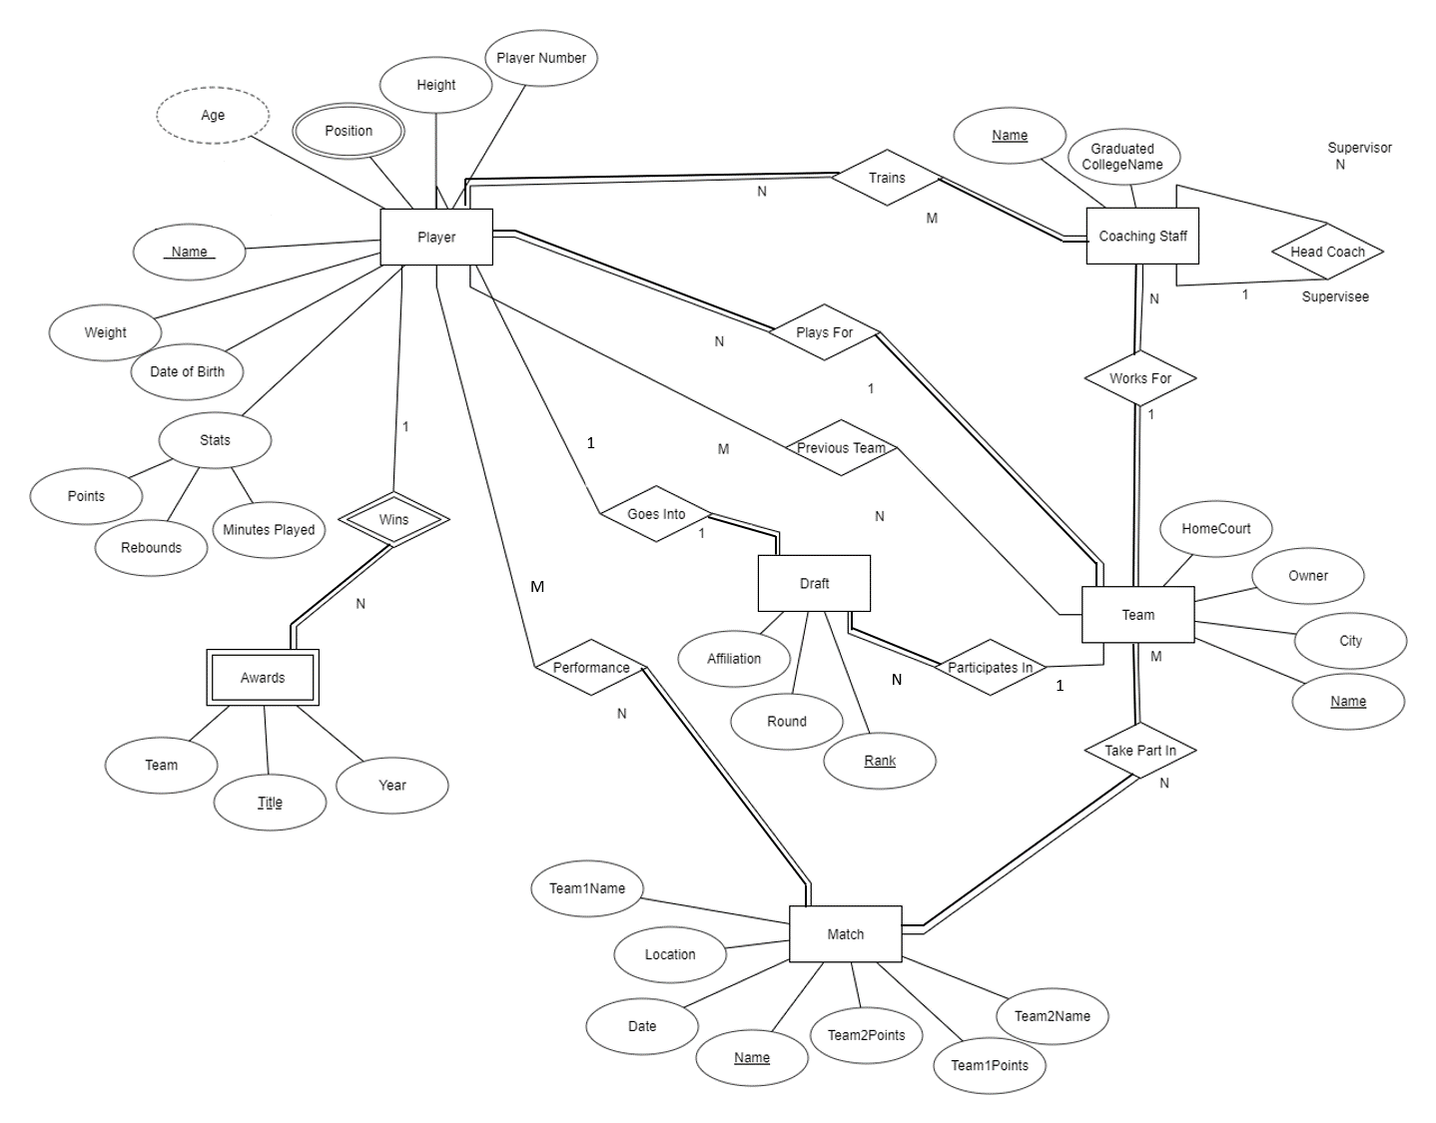

**(2) Complete Relational Schema Diagram (Hard Copy)**

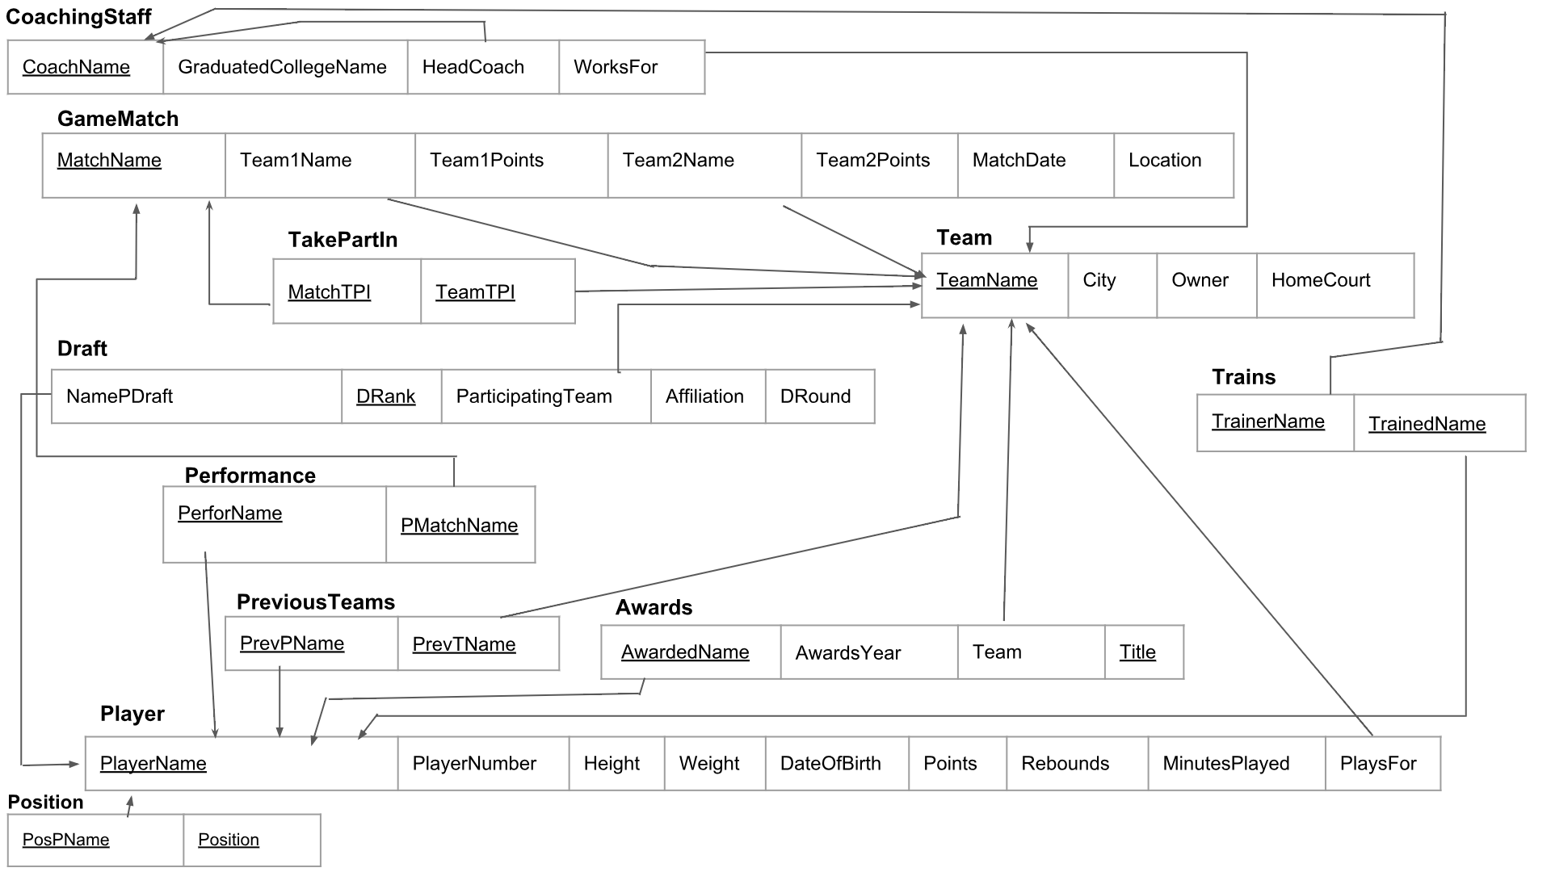

**(3) Oracle DDL codes for implementation your database. Write it in a text file.**

**(Hard Copy)**

DROP TABLE Player CASCADE CONSTRAINTS;

DROP TABLE CoachingStaff CASCADE CONSTRAINTS;

DROP TABLE Awards CASCADE CONSTRAINTS;

DROP TABLE Draft CASCADE CONSTRAINTS;

DROP TABLE Team CASCADE CONSTRAINTS;

DROP TABLE GameMatch CASCADE CONSTRAINTS;

DROP TABLE Trains CASCADE CONSTRAINTS;

DROP TABLE PreviousTeam CASCADE CONSTRAINTS;

DROP TABLE Performance CASCADE CONSTRAINTS;

DROP TABLE Position CASCADE CONSTRAINTS;

DROP TABLE TakePartIn CASCADE CONSTRAINTS;

CREATE TABLE CoachingStaff(

CoachName VARCHAR2(40) CONSTRAINT CoachingStaff_CoachName_PK PRIMARY KEY,

GraduatedCollegeName VARCHAR2(40),

HeadCoach VARCHAR2(40),

WorksFor VARCHAR2(30));

CREATE TABLE GameMatch(

MatchName VARCHAR2(30) CONSTRAINT Match_MatchName_PK PRIMARY KEY,

Team1Name VARCHAR2(30),

Team1Points NUMBER(3),

Team2Name VARCHAR2(30),

Team2Points NUMBER(3),

MatchDate DATE,

Location VARCHAR2(40));

CREATE TABLE TakePartIn(

MatchTPI VARCHAR2(30),

TeamTPI VARCHAR2(30),

CONSTRAINT TakePartIn_MultiTPI_PK PRIMARY KEY(MatchTPI, TeamTPI));

CREATE TABLE Team(

TeamName VARCHAR2(30) CONSTRAINT Team_TName_PK PRIMARY KEY,

City VARCHAR2(20),

Owner VARCHAR2(50),

HomeCourt VARCHAR2(50));

CREATE TABLE Draft(

NamePDraft VARCHAR2(20),

DRank NUMBER(3) CONSTRAINT Draft_Rank_PK PRIMARY KEY,

ParticipatingTeam VARCHAR2(30),

Affiliation VARCHAR2(30),

DRound NUMBER(2));

CREATE TABLE Trains(

TrainedName VARCHAR2(20),

TrainerName VARCHAR2(40),

CONSTRAINT Trains_MultiTrains_PK PRIMARY KEY(TrainedName, TrainerName));

CREATE TABLE Performance(

PerforName VARCHAR2(20),

PMatchName VARCHAR2(20),

CONSTRAINT Performance__PK PRIMARY KEY(PerforName, PMatchName));

CREATE TABLE PreviousTeam(

PrevPName VARCHAR2(30),

PrevTName VARCHAR2(30),

CONSTRAINT PreviousTeam_MultiPT_PK PRIMARY KEY(PrevPName, PrevTName));

CREATE TABLE Awards(

AwardedName VARCHAR2(20),

Title VARCHAR2(80),

TName VARCHAR2(20),

AwardYear NUMBER(4),

CONSTRAINT Awards_MultiAwards_PK PRIMARY KEY(AwardedName, Title));

CREATE TABLE Player(

PlayerName VARCHAR2(30) CONSTRAINT Player_FirstName_PK PRIMARY KEY,

PlayerNum NUMBER(3),

Height VARCHAR2(4),

Weight NUMBER(3),

DateOfBirth DATE,

Points NUMBER(3,1),

Rebounds NUMBER(3,1),

MinutesPlayed NUMBER(3,1),

PlaysFor VARCHAR2(30));

CREATE TABLE Position(

PosPName VARCHAR2(30),

Pos VARCHAR(20),

CONSTRAINT Position_PosPName_Pos_PK PRIMARY KEY(PosPName, Pos));

ALTER TABLE Trains

ADD CONSTRAINT Trains_Pname_FK FOREIGN KEY(TrainedName)

REFERENCES Player(PlayerName);

ALTER TABLE Trains

ADD CONSTRAINT Trains_TrainerName_FK FOREIGN KEY(TrainerName)

REFERENCES CoachingStaff(CoachName);

ALTER TABLE GameMatch

ADD CONSTRAINT GameMatch_Team1Name_FK FOREIGN KEY(Team1Name)

REFERENCES Team(TeamName);

ALTER TABLE GameMatch

ADD CONSTRAINT GameMatch_Team2Name_FK FOREIGN KEY(Team2Name)

REFERENCES Team(TeamName);

ALTER TABLE TakePartIn

ADD CONSTRAINT TakePartIn_TeamTPI_FK FOREIGN KEY(MatchTPI)

REFERENCES GameMatch(MatchName);

ALTER TABLE TakePartIn

ADD CONSTRAINT TakePartIn_MatchTPI_FK FOREIGN KEY(TeamTPI)

REFERENCES Team(TeamName);

ALTER TABLE PreviousTeam

ADD CONSTRAINT PreviousTeam_PrevPName_FK FOREIGN KEY(PrevPName)

REFERENCES Player(PlayerName);

ALTER TABLE PreviousTeam

ADD CONSTRAINT PreviousTeam_PrevTName_FK FOREIGN KEY(PrevTName)

REFERENCES Team(TeamName);

ALTER TABLE Awards

ADD CONSTRAINT Awards_Pname_FK FOREIGN KEY(AwardedName)

REFERENCES Player(PlayerName);

ALTER TABLE Awards

ADD CONSTRAINT Awards_TeamName_FK FOREIGN KEY(TName)

REFERENCES Team(TeamName);

ALTER TABLE Performance

ADD CONSTRAINT Performance_PFname_FK FOREIGN KEY(PerforName)

REFERENCES Player(PlayerName);

ALTER TABLE Performance

ADD CONSTRAINT Performance_Mname_FK FOREIGN KEY(PMatchName)

REFERENCES GameMatch(MatchName);

ALTER TABLE CoachingStaff

ADD CONSTRAINT CoachingStaff_HeadCoach_FK FOREIGN KEY(HeadCoach)

REFERENCES CoachingStaff(CoachName);

ALTER TABLE Position

ADD CONSTRAINT Position_Pname_FK FOREIGN KEY(PosPName)

REFERENCES Player(PlayerName);

ALTER TABLE Player

ADD CONSTRAINT Player_PlaysFor_FK FOREIGN KEY(PlaysFor)

REFERENCES Team(TeamName);

ALTER TABLE Draft

ADD CONSTRAINT Draft_ParticipatingTeam_FK FOREIGN KEY(ParticipatingTeam)

REFERENCES Team(TeamName);

ALTER TABLE Draft

ADD CONSTRAINT Draft_NameDraft_FK FOREIGN KEY(NamePDraft)

REFERENCES Player(PlayerName);

ALTER TABLE CoachingStaff

ADD CONSTRAINT CoachingStaff_WorksFor_FK FOREIGN KEY(WorksFor)

REFERENCES Team(TeamName);

**(5-6) Written report on part2 of this assignment including the relational algebra queries and the meaning of the queries in English. (hard copy) Oracle code and results (show the snapshot of the results in Oracle) on part3 of this assignment**

SQL is a database management language that allows you to construct and manipulate a database, and in doing so, anyone is able to use relational queries to retrieve and obtain specific information from the database. Constructing and managing the database is self explanatory, but how exactly does relational queries work? A relational query is a mathematical way to navigate a database system in real-world situations.

**2 relations**

1. Retrieve the first name and last name of players who scored more than 20 points and took part in the BKN vs BOS game.

**P1← π PerforName ( $σ$ ( matchName = ‘BKN VS BOS’) ( Performance))**

**P2 ← P1⋈ PerforName = PlayerName Player**

**π PlayerName, PlaysFor ( $σ$ (points >20) P2)**

--DML Code--

Create table T1 as

Select PerforName

From Performance

Where PmatchName = ‘BKN vs BOS’;

Select PlayerName, PlaysFor

From T1, Player

Where (Points > 20) AND (PerforName = PlayerName);

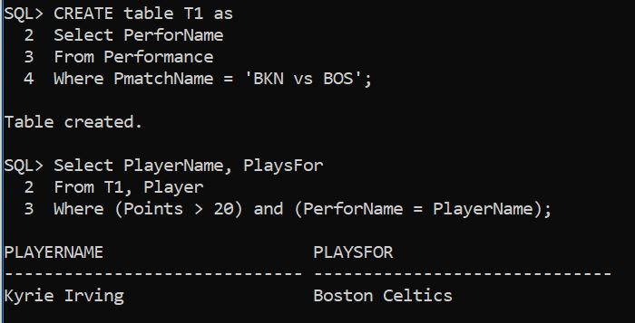

1. List all players who are more than 200 lbs and have won a NBA award.

**P1 ←π** AwardedName **(**AwardedName **Ʒ (** Awards**))**

**P2 ← P1⋈ AwardedName = PlayerName Player**

**π PlayerName, PlaysFor ( $σ$ (weight >200) P2 )**

--DML Code--

Create table T1 as

Select AwardedName

From Awards

Group By AwardedName;

Select PlayerName, PlaysFor

From Player, t1

Where weight > 200 AND playerName = AwardedName;

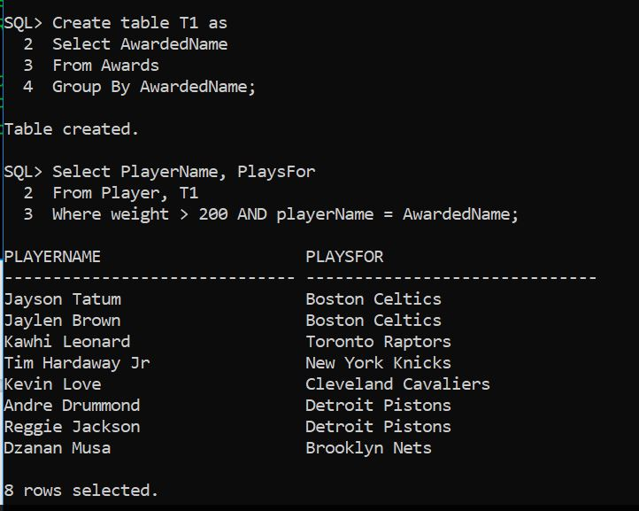

1. List the top 10 picks of the draft who got awarded, their points and the titles of the awards.

**R ←π NamePDraft ( $σ$ (DRank <11) Draft)**

**Pt ← πPlayerName, Points (R ⋈NamePDraft = PlayerName Player)**

**T ← πAwardedName, Title (R ⋈ NamePDraft = AwardedName Awards)**

**Result ← πAwardedName, Points, Title (Pt ⋈ PlayerName= AwardedNameT)**

---DML code---

Create Table R as

Select NamePDraft

From Draft

Where DRank < 11;

Create Table Pt as

Select Points, PlayerName

From R, Player

Where NamePDraft = PlayerName;

Create table T as

Select Title, AwardedName

From R, Awards

Where NamePDraft = AwardedName;

Create Table Result as

Select AwardedName, Points, Title

From Pt, T

Where PlayerName = AwardedName;

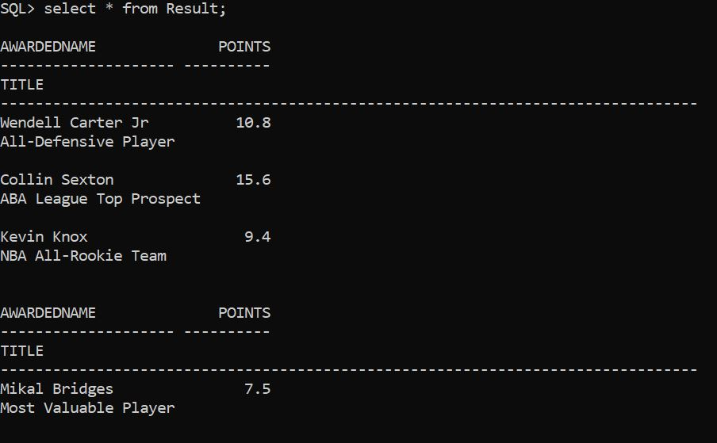

1. List the players who have more than 4 rebounds in the BKN vs BOS game.

**P1← π PerforName ( $σ$ ( PmatchName = ‘BKN VS BOS’) ( Performance))**

**P2 ← P1⋈ PerforName = PlayerName (Player)**

**Result ← π PlayerName( $σ$ (rebounds>4) (P2))**

--DML Code--

Create table P1 as

Select PerforName

From Performance

Where PmatchName = ‘BKN vs BOS’;

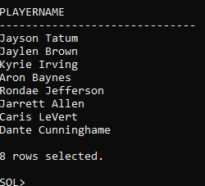

1. What’s the max weight of a player coming from the draft pick and what team does he belong to?

**P1← π NamePDraft( $σ$ NamePDraft( Draft))**

**P2 ← π PlayerName, Weight (P1⋈ NamePDraft= PlayerName (Player))**

**π PlayerName, Weight( Ʒ MAX Weight (P2))**

create table p1 as

select NamePDraft

from Draft;

create table p2 as

select playername, weight

from p1, player

where namepdraft = playername;

select playername, weight

from p2

where weight =(select Max(weight) from p2);

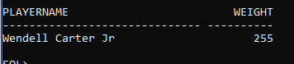

**3 relations**

1. Who is the headcoach of a player who has won an NBA Championship?

**P1 ←π AwardedName ( $σ$ Title= ‘NBA Championship’ ( Awards))**

**P2 ←π PlaysFor ( P1⋈ AwardedName = PlayerName Player)**

**Result ←π CoachName ( P2⋈ (PlaysFor = WorksFor) CoachingStaff)**

--DML CODE--

Create Table Champions as

Select AwardedName

From Awards

Where Title = 'NBA Championship';

Create Table TeamPlayingFor as

Select PlaysFor

From Player, Champions

Where PlayerName = AwardedName;

Select CoachName

From CoachingStaff, TeamPlayingFor

Where PlaysFor = WorksFor;

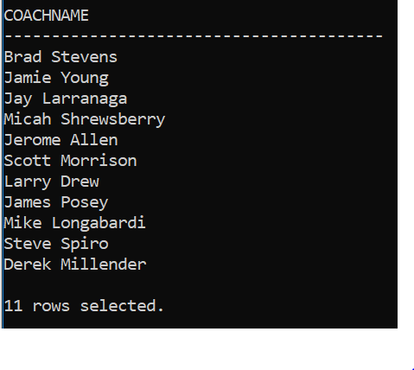

1. What is the most frequency position played by players who play more than 6 minutes per game and are in Los Angeles?

**P1← Pos Ʒ count PosPname (Position)**

**MaxPos ← πPos ( $σ$ Ʒ Max count_PosPName(P1) = count_PosPName (P1) )**

**T1 ← MaxPos⋈ Pos= Pos Position )**

**P2← $σ$ city = ‘Los Angeles’(Team)**

**T2 ← $σ$ minutesplayed >6 ( P2⋈ TeamName = PlaysFor Player)**

**Result ← T1⋈ PosPName = PlayerName T2**

Create Table P1 as

Select Pos, Count(PosPName) count_num

from position

Group by Pos;

Create table MaxPos as

select Pos

from P1

where count_num = (select Max(count_num) from P1);

create table T1 as

select PosPName, M.Pos

from MaxPos M, Position P

where M.pos = P.pos;

Create Table P2 as

select TeamName

from Team

where city = 'Los Angeles';

Create table T2 as

select *

from P2, Player

where minutesPlayed > 6 And TeamName = PlaysFor;

create table result as

select PlayerName, TeamName, Pos

from T1, T2

where PosPName = PlayerName;

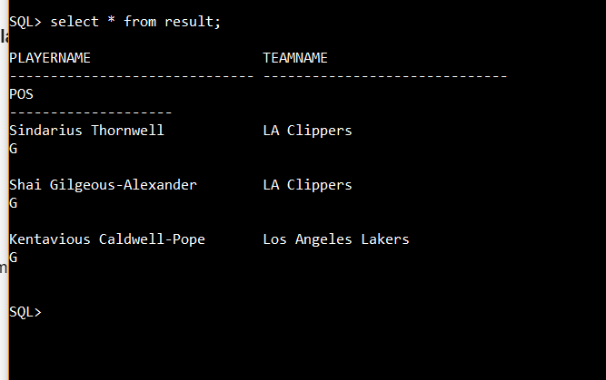

1. What’s the name of the head coach that trains the guard with the highest ppg in the Washington Wizards?

**T1 ← π PosPName, Pos, Points ( $σ$ PosPName = PlayerName( $σ$ PlaysFor= ‘Washington Wizards’ (Player))(Position));**

**M1 ← πPlayerName($σ$ Ʒ MaxPoints = Points(T1))**

**T2 ← π TrainerName( P1⋈ PlayerName = TrainedName (Trains))**

**Result ←π HeadCoach( P2⋈ TrainerName = CoachName (CoachingStaff))**

Create table T1 as

Select PlayerName, Points

From Player

Where PlaysFor = ‘Washington Wizards’;

Create Table T2 as

Select PlayerName, Pos, Points

From T1, Position

Where PlayerName = PosPName AND Pos = ‘G’;

Create Table M1 as

Select PlayerName

From T2

Where Points = (select Max(Points) from t2);

Create Table T3 as

Select TrainerName

From Trains, M1

Where TrainedName = PlayerName;

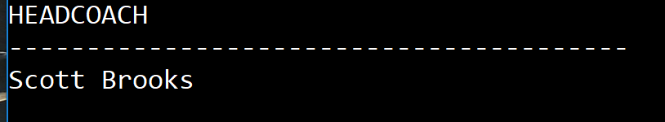

Select HeadCoach

From CoachingStaff, T3

Where CoachName = TrainerName;

**4 relations**

1. Which coaches trains players play as guard that won at least one awards for Boston?

**T1 ← π TeamName( $σ$ City = ‘Boston’ (Team))**

**P1 ← π AwardedName (T1⋈ TeamName = TName Awards)**

**P2 ← π PosPName($σ$ Pos = ‘G’ (Position))**

**P3 ← P1⋈ AwardedName = PosPName P2**

**Result← π TrainerName, TrainedName ( P3⋈ AwardedName = TrainedName (Trians))**

create table t1 as

select teamName

from Team

where city = 'Boston';

create table p1 as

select awardedName

from T1, Awards

where TeamName = TName;

create table P2 as

select PosPName

from Position

where Pos = 'G';

create table P3 as

select AwardedName

from P1,P2

where AwardedName = PosPName;

Create table result as

select TrainerName, TrainedName

from P3, Trains

where AwardedName = TrainedName;

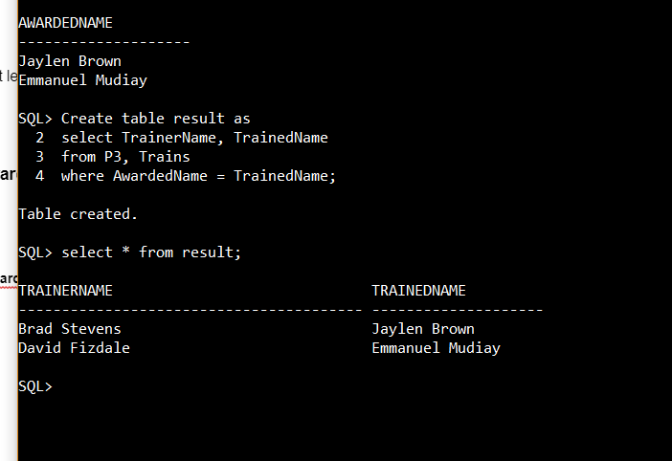

1. Find the number of players , number of coaches, number of Award by a team have Mikhail Prokhorov as owner?

**T1← π TeamName ( $σ$ Owner = ‘Cablevision’ (Team) )**

**P1 ← Ʒ count PlayerName ( T1⋈ TeamName = Playsfor Player )**

**P2 ← Ʒ count CoachName(T1⋈ TeamName = WorksFor CoachingStaff)**

**P3 ← Ʒ count AwardedName (T1⋈ TeamName = Team Awards)**

**Result ← T1* P1*P2*P3**

Create Table T1 as

select Owner, TeamName

from Team

where Owner = ‘Mikhail Prokhorov’;

Create Table P1 as  
 select count(PlayerName) count_players  
 from Player, T1  
 where TeamName = PlaysFor;

Create Table P2 as

select count(CoachName) count_coaches

from CoachingStaff, T1

where TeamName = WorksFor;

Create Table P3 as

select count(AwardedName) count_Awards

from Awards, T1

where TeamName = TName;

Create Table Result as

select Owner, TeamName, count_players, count_coaches, count_Awards

from T1,P1,P2,P3;

